Documentation by Simerpreet Singh

Introduction:-

The work is done on the assignment Russian roulette game.The game is made by microsoft visual studio.which is about a popular shooting randomly.According to the assignment if player suceed on the first try by firing the gun,he/she will get 10 points. If the player fails,he/she can retry to shoot.game named Russian roulette,In which an individual player plays with the gun which fires

Design:-

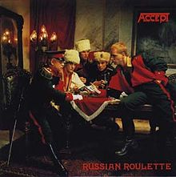

This picture above the text is background image to make the game look more attractive. The source of the wallpaper and other gif files used to design is google images. I designed the buttons and added picture box via visual studio. The gifs which are inserted in the game application are following. 

Functioning:-

So basically,when we start the game application there is a activated gif image presented on the left side on first form. The title says “welcome to the russian roulette.” The player writes his/her name in the text box. Afterwards the player may hit the PLAY button and then ables to start the game by entering the second page of the form.

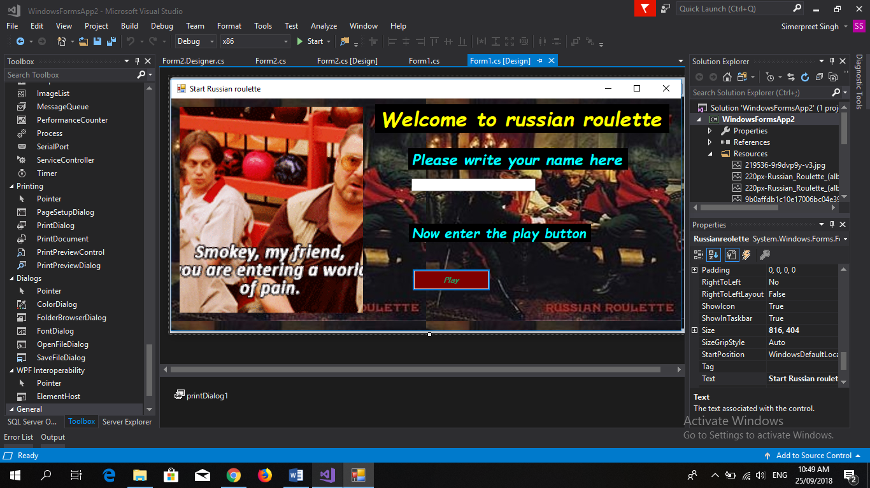

There are five buttons-load,spin,shoot,try again and exit respectively. Each of them are fully functional and complete their existing purpose. The click on load button starts a gif showing a revolver load only with just one bullet as the game rules say so. Afterwards spin button randomly spins the chamber of the revolver. If the luck is good of the player,he/she may win the game if gun fires by hitting the shoot button. The player can retry by help of retry button if fails. There is a exit button at the last from where we can exit.

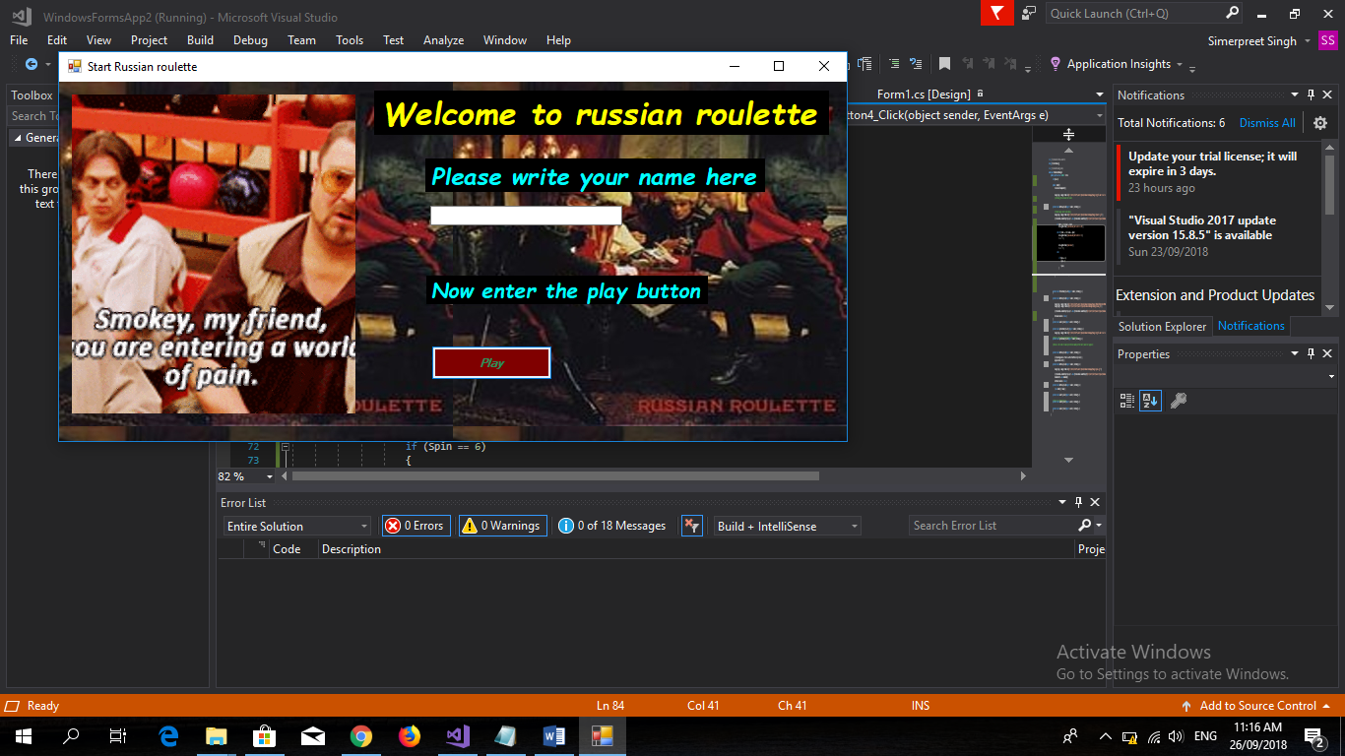

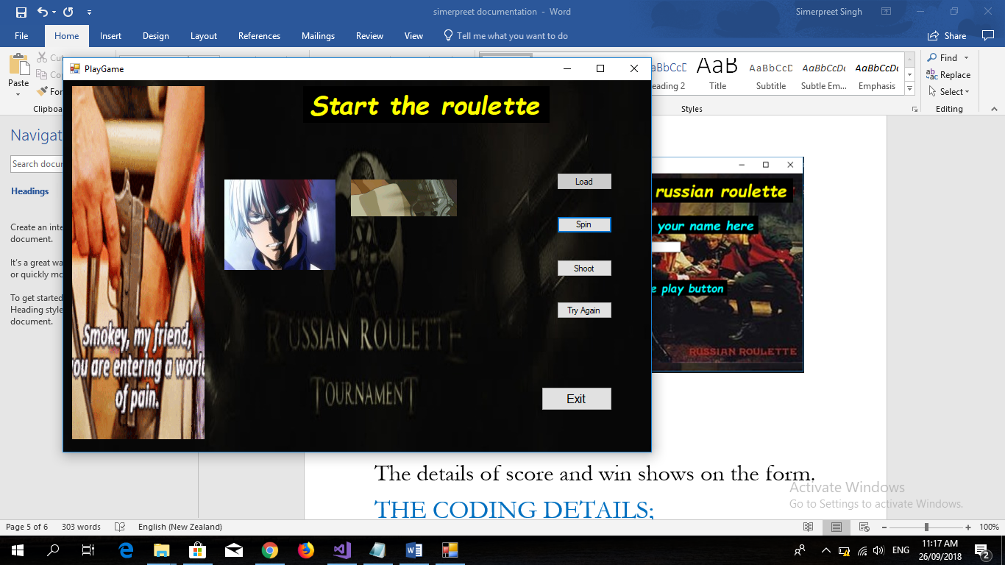

The details of score and win shows on the form.

THE CODING DETAILS;

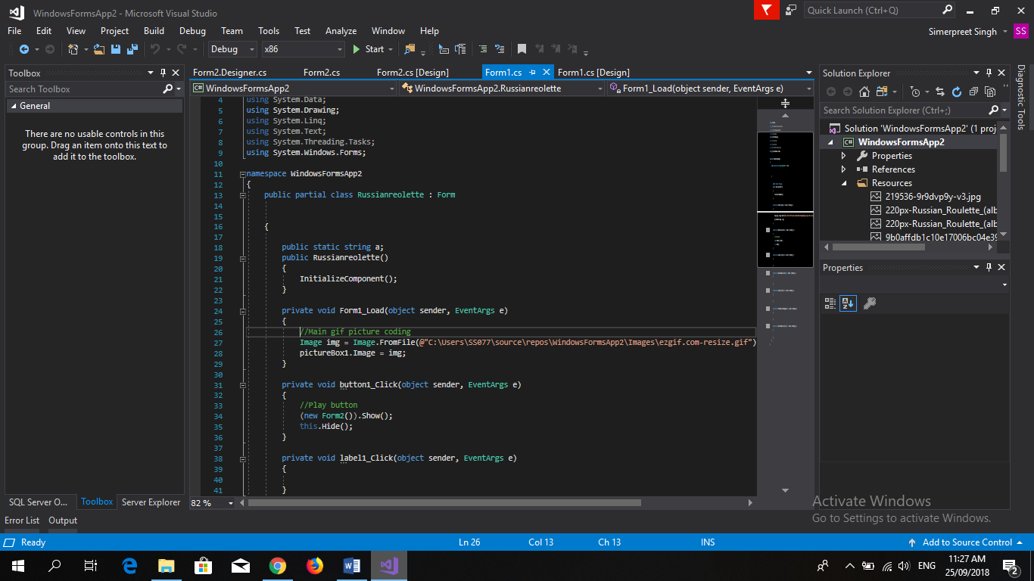

This is the coding done in the visual studio for form1&form2 respectively.

